When I enter a new item, it is displayed all in upper case, whether or not I have Caps Lock switched off or on:
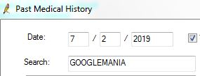
However, once I have added that new item to the list, it is displayed with only this first letter in upper case:
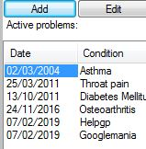
This is annoying, because when I enter ‘HelpGP’ (which is the name of a research study), it is displayed as ‘Helpgp’.
Please can Best Practice let us enter new history items exactly as we want them to be displayed?

