Follow up actions from In Box

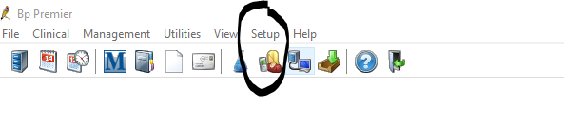
Can no longer select multiple patients with shift
